

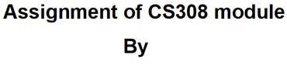
Group |  | 26
No. | Student ID | Student Full Name | Signature (please insert here)
1 |  | Rebecca Fyfe
2 |  | Kyle McCann
3 | 202339577 | Rosie O'Donnell
4 | 202316432 | Cara Reid
5 |  | Amy Watson

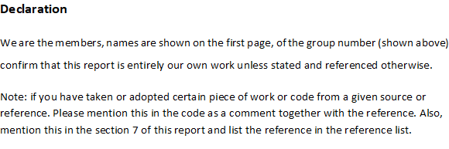

- User requirements
Provide a list of the user requirements that explain the tasks associated with this software.
  - Users (students or lecturers) should be able to sign up to the management system so that their account information saved on to the system.
    - Given a user wants to sign up to the management system, when the user enters their correct details, then the user will be put on the sign-up workflow to wait for approval from a manager.
    - Given a user wants to sign up to the management system, when the user enters the incorrect details, then the user will be prompted to re-enter their details.
  - Users (student, lecturer or manager) should be able to login to their designated account so that they are able to access all relevant materials.
    - Given the user has an account, when the user attempts to log into the system, then they can access their relevant information.
    - Given the user doesn’t have an account, when the user attempts to log into the system, then an error message will be displayed.
  - Users (students) should be able to view their course modules, so that the user is able to see what modules they are enrolled in.
    - Given the user is enrolled in a course, when they request to view their modules, then a list of their modules will be shown.
    - Given the user is not enrolled in any modules, when they request to view their modules, then none will be shown.
  - Users (students) should be able to view their achieved marks for each module, so users can see what modules they did best in.
  - Users (students) should be able to download a specific lab and lecture note from a certain week, so that they can review and study these notes when they are home.
    - Given there are notes for the module, when the student goes to download them, then a local copy will be made.
    - Given there are no notes for the module, when the student goes to download them, then an error message will be displayed.
  - Users (students) should be able to view the decision made for their course, so that they are able to assess whether they have passed or failed their course.
    - Given a decision has been made, when a student requests to see the decision for their course, then their decision will be shown.
    - Given that no decision has been made, when a student requests to see the decision for their course, then no decision will be displayed.
    - Given all modules in their enrolled course have a pass mark, when the user requests to view their decision, then their decision will be Award.
    - Given that not all modules in their enrolled course have a pass mark, when the user requests to view their decision, then their decision will be resit.
    - Given the user attempted all the attempts allowed for any module in their course, when the user requests to view their decision, then their decision will be Withdraw.
  - Users (lecturers) should be able to update the information of their dedicated module, so that all information remains relevant.
    - Given the lecturer has the database for all their classes, when a change is needed to be made, then they can modify the classes in whatever way they wish.
  - Users (lecturers) should be able to upload or update module materials for students to view, so that the students will have access to the latest materials when they are available.
    - Given a lecturer is assigned a module, when the user wants to upload lecture materials, the materials will be uploaded to the modules for students to view.
    - Given module materials have been posted, when the user chooses to update the materials, the previous materials will be updated to the new files.
  - Users (lecturers) should be able to view the records of students in their associated class, so that they can provide a list of all their students upon request.
    - Given there are students enrolled in the lecturer’s module, when the lecturer requests to view the records of students, then a list of the students will show.
    - Given there are no students enrolled in the lecturer’s module, when the lecturer requests to view the records of students, then an error message will be displayed.
  - Users (lecturers) should be able to update the exam records of the students enrolled in their module, so that each student can be given a grade on their record for each exam.
    - Given there are students enrolled in the lecturer’s module, when the lecturer updates the exam records for a student, then these updates will be saved to the student’s record.
    - Given there are no students enrolled in the lecturer’s module, when the lecturer tries to update records for a student, then an error message will be displayed.
  - Users (managers) should be able to view the sign-up workflow and be able to approve students and lecturers, so that if any students or lecturers do sign up for an account they can either be approved or denied.
    - Given there are users in the sign-up workflow, when the workflow is viewed, then users can be approved or denied.
    - Given there are no users in the sign-up workflow, when the workflow is viewed, a message stating there are no pending records will appear.
  - Users (managers) should be able to manage other user’s accounts, so that the manager modifies their accounts for things such as changing modules/courses.
    - Given that the user can manage other accounts, when the user wants their password to be reset, then the manager can reset that user’s password.
    - Given that the user can manage other accounts, when an account is to be activated or deactivated, then the manager can activate or deactivate the user’s account.
  - Users (managers) should be able to assign a module to a given lecturer, so that I can choose what lecturers are teaching which class.
    - Given that a module doesn’t have a lecturer assigned, when a lecturer is assigned to that module, they are able to manage that class.
  - Users (managers) should be able to enroll students to a given course, so that if requested, the manager can approve and enroll students in their chosen course.
    - Given that a student wants to be enrolled on a course, when a student is added to a course, they are enrolled onto the system and can access all the course materials.
  - Users (managers) should be able to issue a decision to a student user, so that students are able to know what their results are.
    - Given that the user can access the student database, when viewing student information, then decisions can be issued for this class of user.
  - Users (managers) should be able to change the maximum number of attempts that can be made for each module, so that the manager can increase or decrease the number of attempts as needed.
    - Given the user is a manager, when the user increases the maximum number of attempts, then students will be able to sit the module more times.
    - Given the user is a manager, when the user decreases the maximum number of attempts, then students will not be allowed to sit the module as many times.
  - Users (managers) should be able to change the number of modules that are allowed to be compensated, so that the system reflects the accurate number of allowed compensations.
    - Given the course allows compensated modules, when the manager increases the number of modules that can be compensated, then that number will update for students.
    - Given the course allows compensated modules, when the manager decreases the number of modules that can be compensated, then that number will update for students.
  - Users (managers) should be able to add new courses and modules to the system, so that if a new class is created, the manager can add new courses and modules correlating to the change made to the system.
    - Given that the user has access to the courses and modules database, when lecturers have new classes that they can teach, then new courses and modules can be added.
  - Users (managers) should be able to assign a module to a course so that the course includes the added module.
    - Given that a module exists, when a manager wants to add a new module to a course, the module can be added to the course.
  - Users (managers) should be able to display course and module details, so that if requested, the manager can bring up a list of available courses and modules and show information on any that may be inquired upon.
    - Given that a course or module exists, when the user searches a course or module, then the details are displayed for each course and module.
  - Users (managers) should be able to update course information, so that if any course changes are added, it can be implemented on the management system too.
    - Given that a course exists, when the manager updates the course information, then those changes will be applied to any students taking the course.

- System Requirements
  - System use case diagram
Provide a use case diagram as a figure within the text and as a sperate image file called SUCDrgm.tiff or any other format (such as pdf) that can be zoomed in/out to display use cases and relationships.
  - System use case (SUC) details
Provide a tabular description (or narratives) to the following system use cases
- Signup (for any user: lecture or student)
- Approve users
- Update password
- Validate login
- Enroll a student in a course
- Add a business rule
- Issue student decision
- Manage other user account
that explain these System Use Cases to developers. Each description has to describe one use case. For example, the following table describe a login system use case:
SUC name | Login
Actor | System user
Supporting actor | None
Pre-condition | User has an account
Trigger | User requests to login (e.g., by merely running the App)
Main Scenario | - The system prompts the user to provide a username and password  - The user inputs the required details and submits  - The system invokes validate login use case and returns the result  - If validate login returns True, system hides the login GUI and invokes display Commands GUI use case
Alternative scenario | 4.a validate login use case returns (false)  4.a.1. System displays “invalid credentials” message, and increases attempt counter by 1  4.a.2. If the counter value <=3, system redisplays the login GUI. Otherwise, system displays “Too many login attempts” message and exits.
Post-condition | login timestamp is recorded
Table 1. The description of Login SUC

SUC name | Signup
Actor | Student or Lecturer
Supporting actor | Manager
Pre-condition | The user isn’t registered on the system
Trigger | User requests to signup
Main Scenario | 1. The system asks the user what type of account they would like to create (student or teacher)  2. The system prompts the user to provide the correct details dependant on what type of account  3. The system validates that the details are valid  4. The system validates that there is not already an account with those details  5. The system adds the request to the sign-up workflow  6. The manager approves the request
Alternative scenario | 3.a The details are not valid  3.a.1 System displays a message about the user’s invalid credentials  3.a.2 The user is taken back to step 2  4.a There already exists an account with those details  4.a.1 System displays a message that there is already an account with these details  4.a.2 The system takes them to the login section  6.a The manager doesn’t approve the request  6.a.1 The system displays a message letting the user know about the decision  6.a.2 The account is not added to the records
Post-condition | If approved the account is created and added to the records
Table 2. The description of Signup SUC

SUC name | Approve Users
Actor | Manager
Supporting actor | None
Pre-condition | There are users waiting to be approved in the sign-up workflow
Trigger | Manager opens the sign-up workflow
Main Scenario | 1. System Displays all pending sign-up requests  2. Manager can select each request to review it  3. The Manager makes approves the request
Alternative scenario | 1.a There is no pending requests  1.a.1 The system will display a message saying there are no requests pending  3.a The manager denies the request  3.a.1 the decision is set to denied  3.a.2 The user is not added to the system
Post-condition | The decision is returned to the user who sent the approve request  The request is removed from the workflow
Table 3. The description of Approve Users SUC

SUC name | Update Passwords
Actor | System user
Supporting actor | None
Pre-condition | User has an account and password
Trigger | User requests to update password
Main Scenario | 1. System prompts user to provide new password and then input that new password again  2. The user inputs the new required details and submits  3. The system compares the two new passwords and checks to see if they match.  4. If valid, the system updates the password in the database.  5. The system displays a confirmation message ‘Password successfully updated’.
Alternative scenario | 4.a. Passwords do not match.  4.a.1. System displays ‘Incorrect Password’ message.
Post-condition | New password is recorded.
Table 4. The description of Update Passwords SUC

SUC name | Validate Login
Actor | System user
Supporting actor | None
Pre-condition | User inputs a username and password
Trigger | User attempts to login
Main Scenario | - System checks if the user exists in the database.  - If the user exists in the database, then check that the user’s inputted password is correct
Alternative scenario | 1.a The user does not already exist in the database.  1.a.1 The login is therefore not valid.  2.a Password input doesn’t match the stored password  2.a.1 The login is therefore not valid.
Post-condition | User login is validated and user is able to login.
Table 5. The description of Validate Login SUC

SUC name | Enroll a Student in a Course
Actor | Manager
Supporting actor | None
Pre-condition | Student has an existing account
Trigger | Student has an account but does not have a course
Main Scenario | - Student has no courses on their account  - The system assigns the student their course
Alternative scenario | 1.a The student has a course on their account, the course will have to be switched with the correct course
Post-condition | Courses are enrolled in correctly
Table 6. The description of Enroll a Student in a Course SUC

SUC name | Add a Business Rule
Actor | Manager
Supporting actor | None
Pre-condition | There are modules in the system
Trigger | Manager chooses to add a new business rule
Main Scenario | - System asks user what business rule they want to add  - Manager specifies the parameters for said business rule  - Check if the business rule exists, if the business rule doesn’t exist, then it’s okay to add it
Alternative scenario | 2.a If the parameter(s) are out of range (i.e a negative value) then show an error message and prompt the user to retype parameter(s).  3.a If the business rule already exists then update the previous rule with the new rule data.
Post-condition | A business rule has been successfully added
Table 7. The description of Add a Business Rule SUC

SUC name | Issue Student Decision
Actor | Manager
Supporting actor | None
Pre-condition | Student has sat all modules
Trigger | Student requests decision
Main Scenario | - Check all modules have a pass mark  - Student is issued with award
Alternative scenario | 1a.1 There is a module without a pass mark  1a.2 Check if module without pass mark has already been resat  1a.3 Module has not been resat already so student is prompted to resit any failed modules  1b.1.a Module without pass mark has already been resat  1b.1.b Student is prompted to withdraw from course
Post-condition | Student decision is returned
Table 8. The description of Issue Student Decision SUC

SUC name | Manage User Account
Actor | Manager
Supporting actor | Student, Lecturer
Pre-condition | The Student or Lecturer has an existing account to be managed
Trigger | Account requires intervention
Main Scenario | - The student/lecturer requires intervention with their account, whether to activate the account, deactivate, or reset their password  - The system prompts the Manager with the request  - The Manager makes the requested changes to clear the intervention  - The change is made to the account and the issue is solved.
Alternative scenario | 1.a The account doesn’t require intervention, nothing else is done.  1.b A Manager requires account intervention  2.b The manager cannot manage their own account, so it is managed by another manager which will rectify the issue
Post-condition | Account no longer requires intervention
Table 9. The description of Manage User Account SUC

- Database Model
Provide a list of each entity in your E/R diagram and explain very briefly why this entity is required (reflect on the user requirements). For example,
  - Student: An entity which is used to store every individual students’ details and account credentials.
  - StudentCourse: An entity which creates a connection between a student and the course they are enrolled in.
  - Course: An entity which represents a specific academic program and what it is about.
  - CourseModule: An entity which creates a connection between a course and the modules that belong to it.
  - StudentModule: An entity which connects between a student and the modules they take, the results for the module and the attempts made.
  - Module: An entity which represents a specific subject or topic within a course itself.
  - Week: An entity which represents a specific teaching week and its associated content and notes that goes with it.
  - ModuleLecturer: An entity which creates a connection between a module and the lecturer(s) who teach it.
  - Lecturer: An entity which is used to store every individual lecturer’s details and account credentials.
  - Manager: An entity which represents the administrative users who manage and oversee the system.
Then provide the E/R diagram as a Figure within text and also as a separate image file called ERD.tiff or any format (such as pdf) that can be zoomed in/ out to view each field and its type.
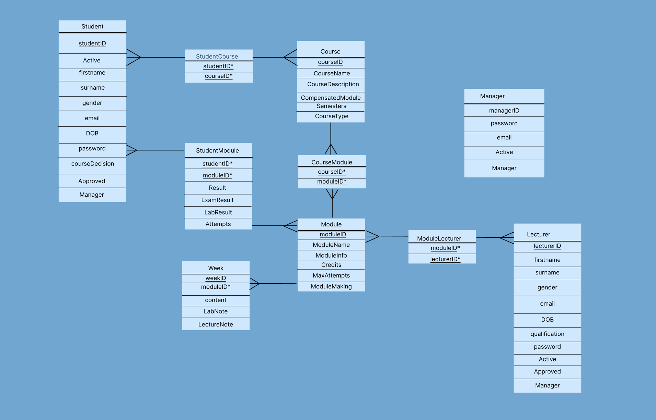

When working in your database model, try to compose the SQL queries that you will use to achieve the user requirements stated in the first section. While you don’t need to state your SQL queries in this section, these will be used in your implementation.

- GUI Design
Provide figures as screen shots of all the GUIs that you have designed. Please provide a figure caption to explain what the figure shows. For example,
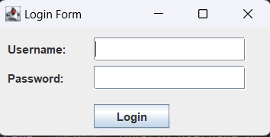
Figure 4.1 the Login GUI
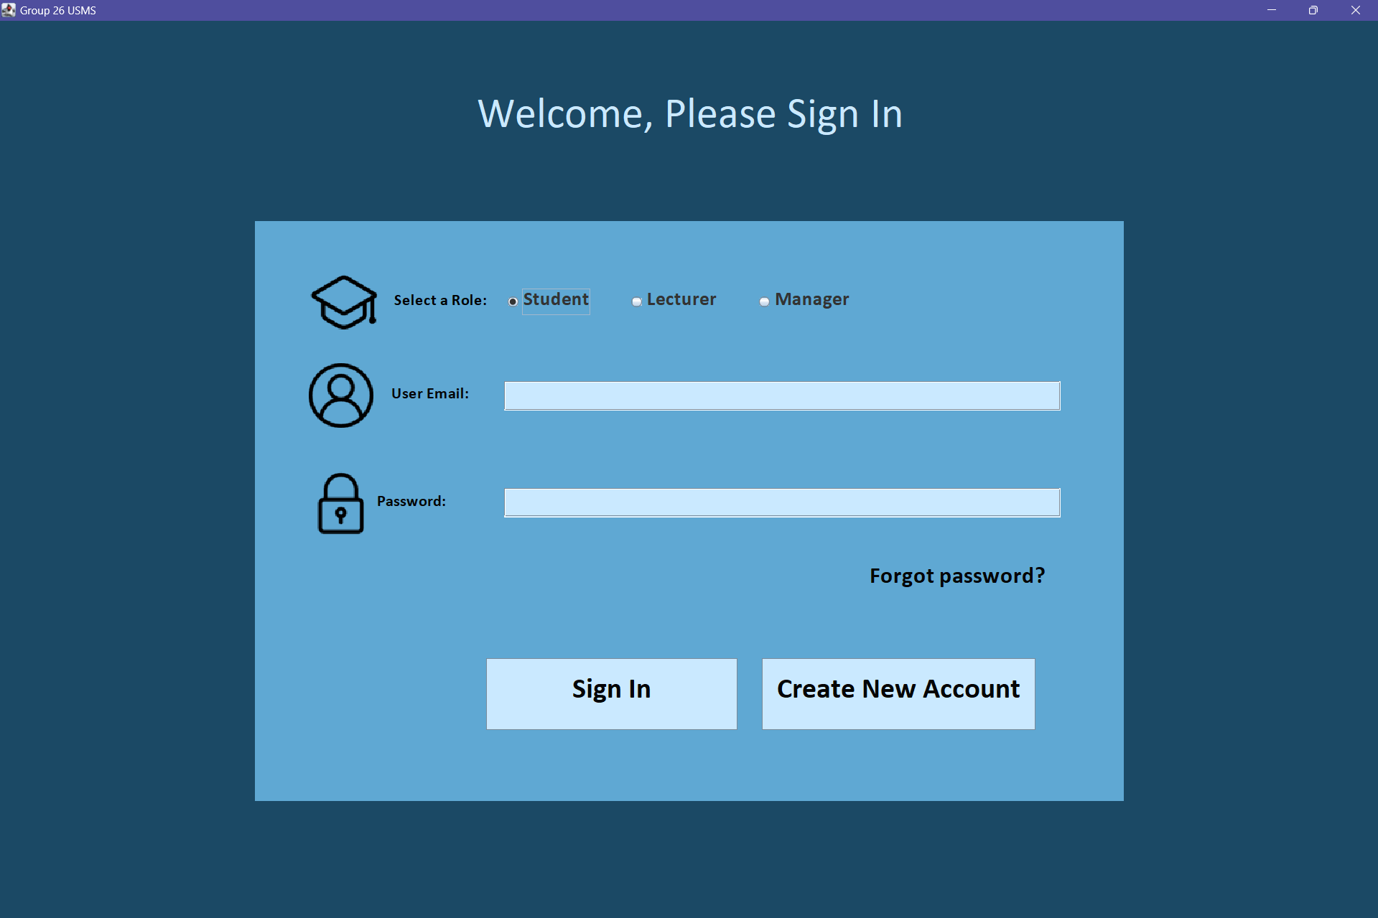
Figure 4.1 the Login GUI
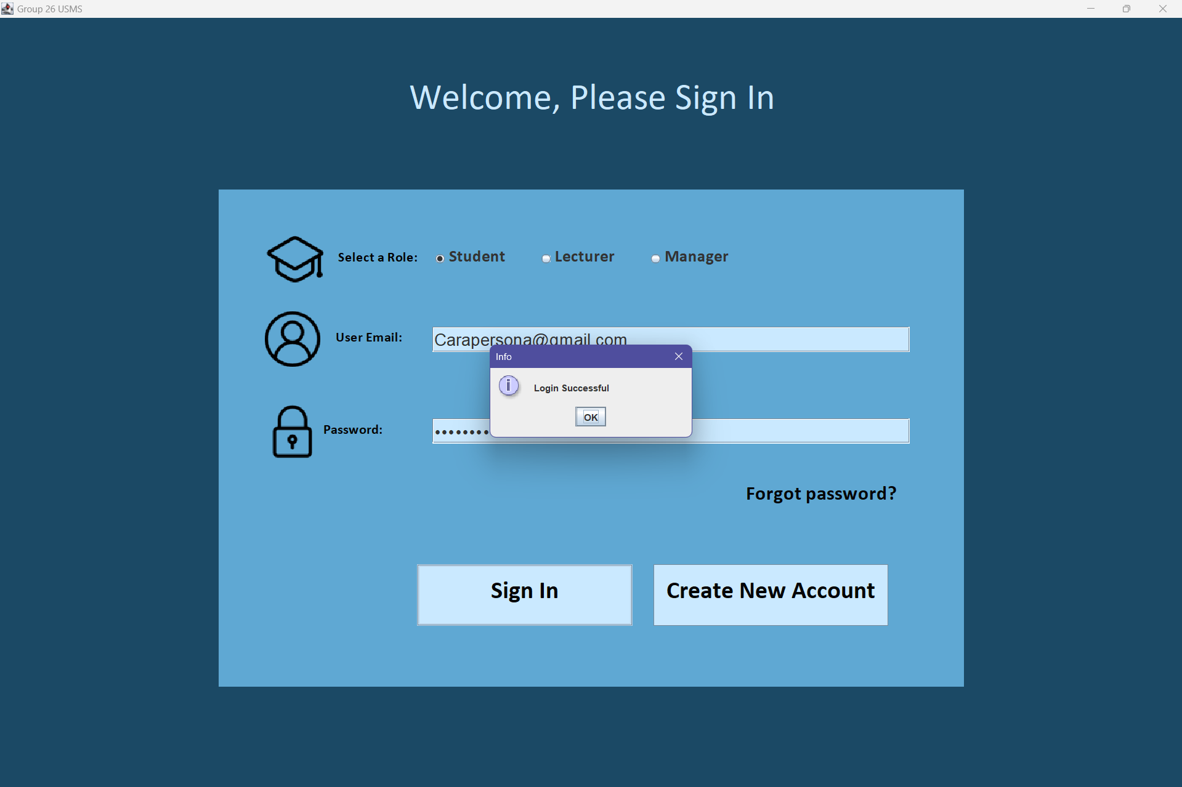
Figure 4.2, successful login GUI

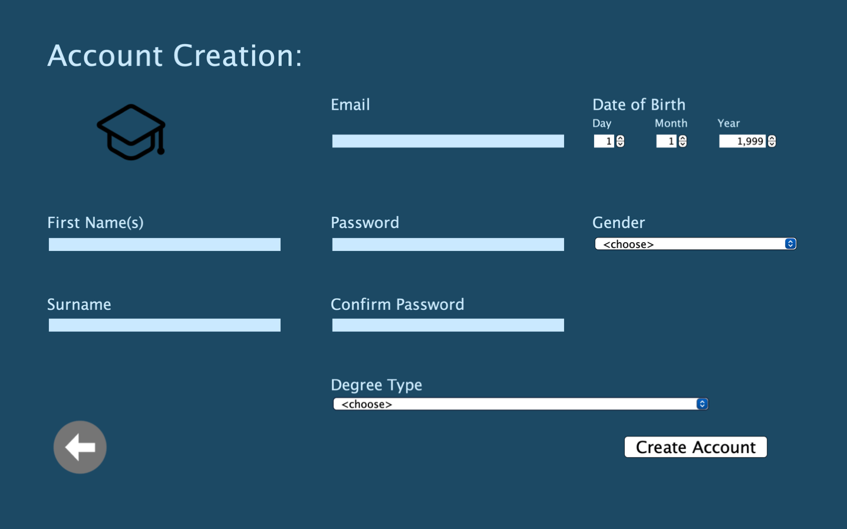
Figure 4.3, student account creation GUI
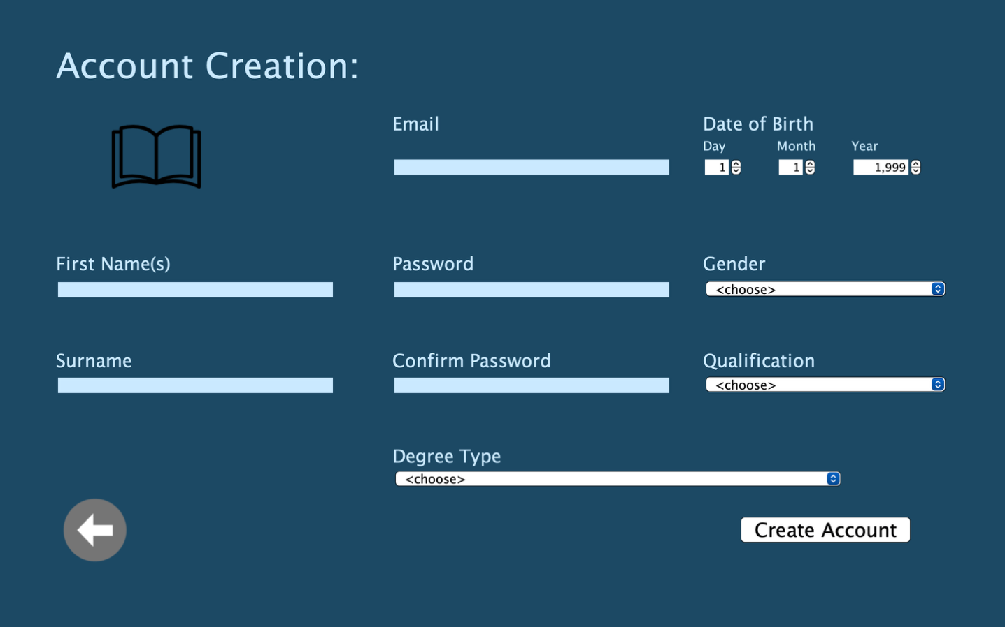
4.4, lecturer account creation GUI
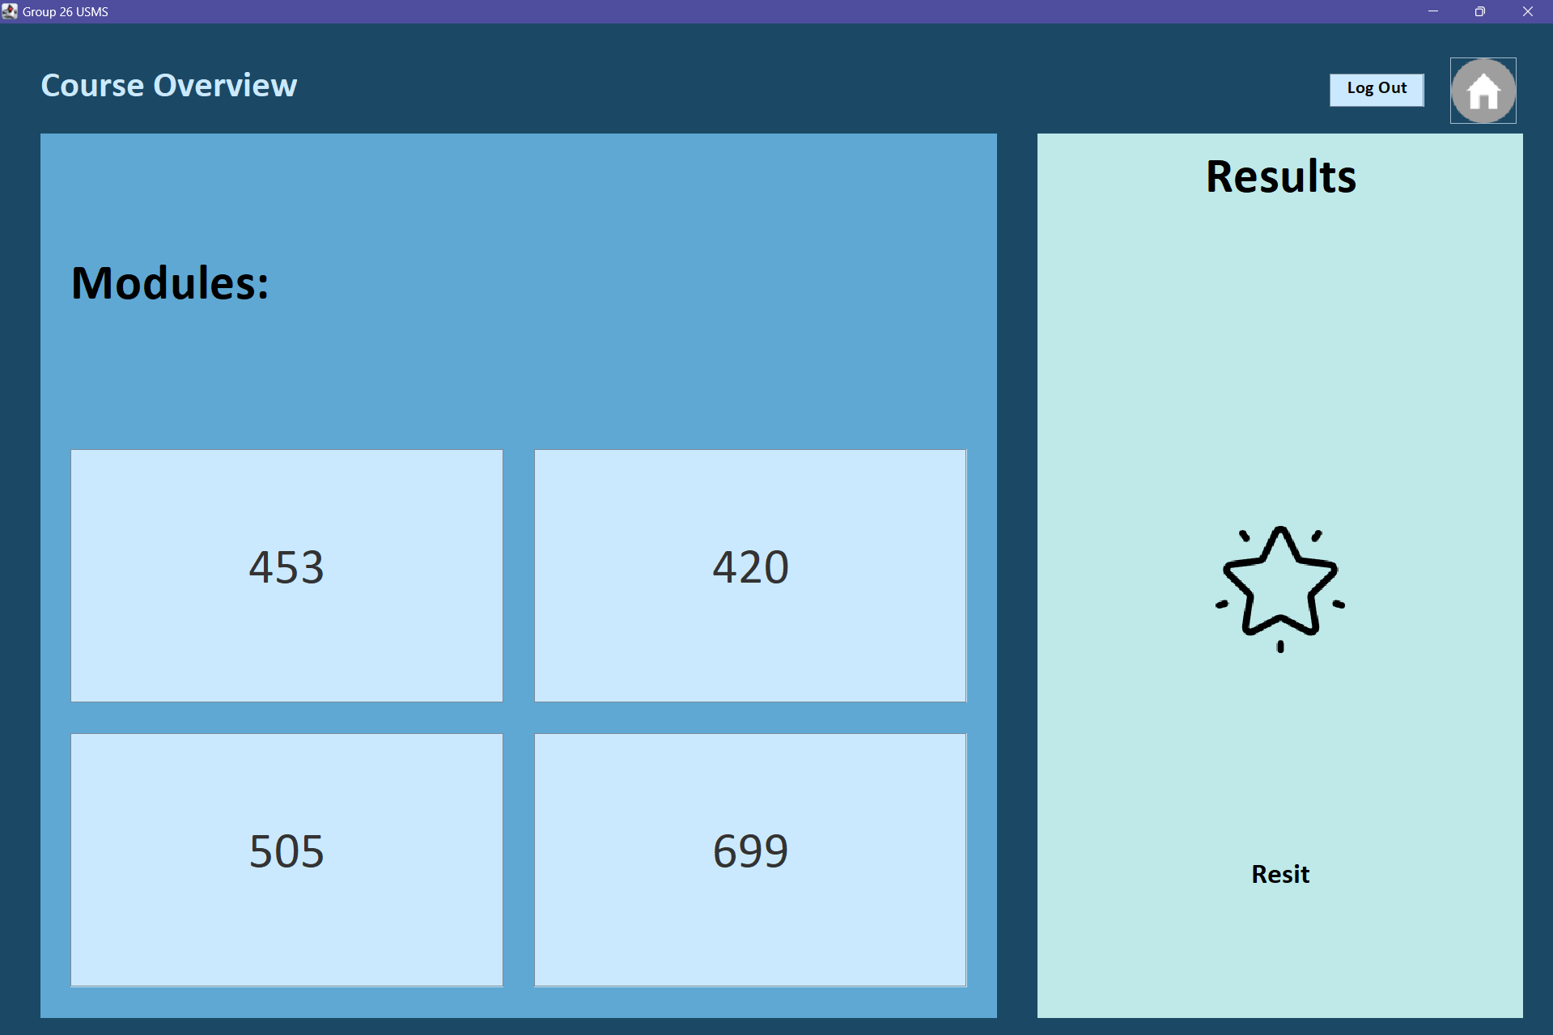
Figure 4.5, course overview for students GUI, modules students selected included

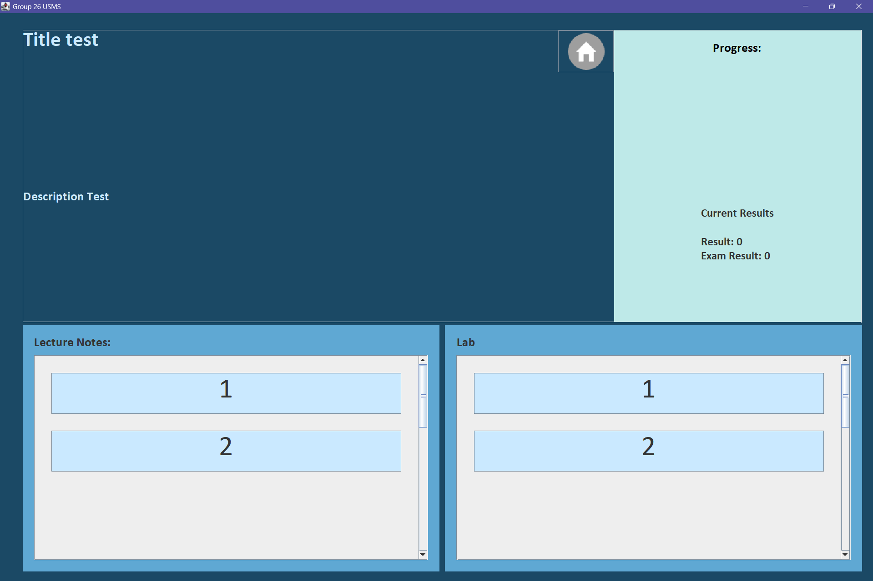
Figure 4.6, student display of specific selected module GUI from previous course overview page

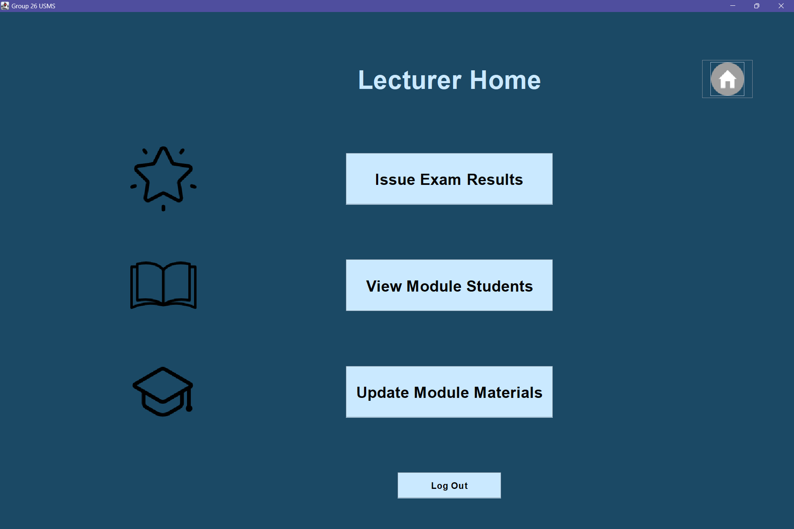
Figure 4.7, lecturer home page GUI

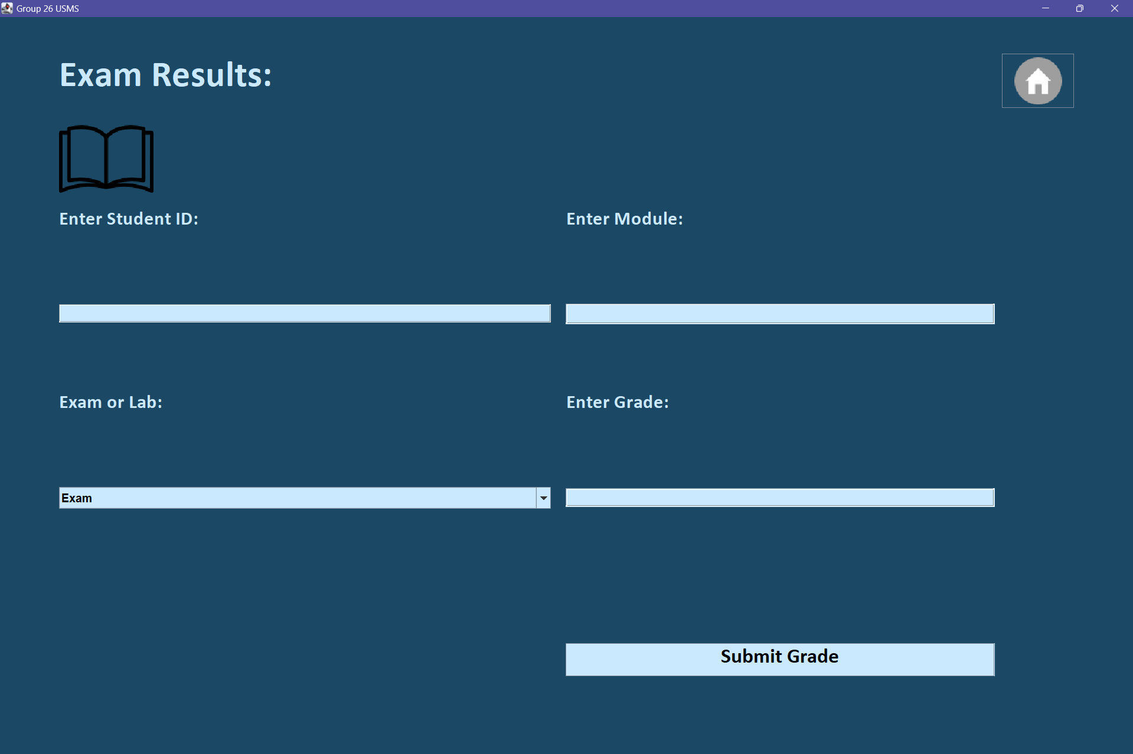
Figure 4.8, exam results GUI for lecturer

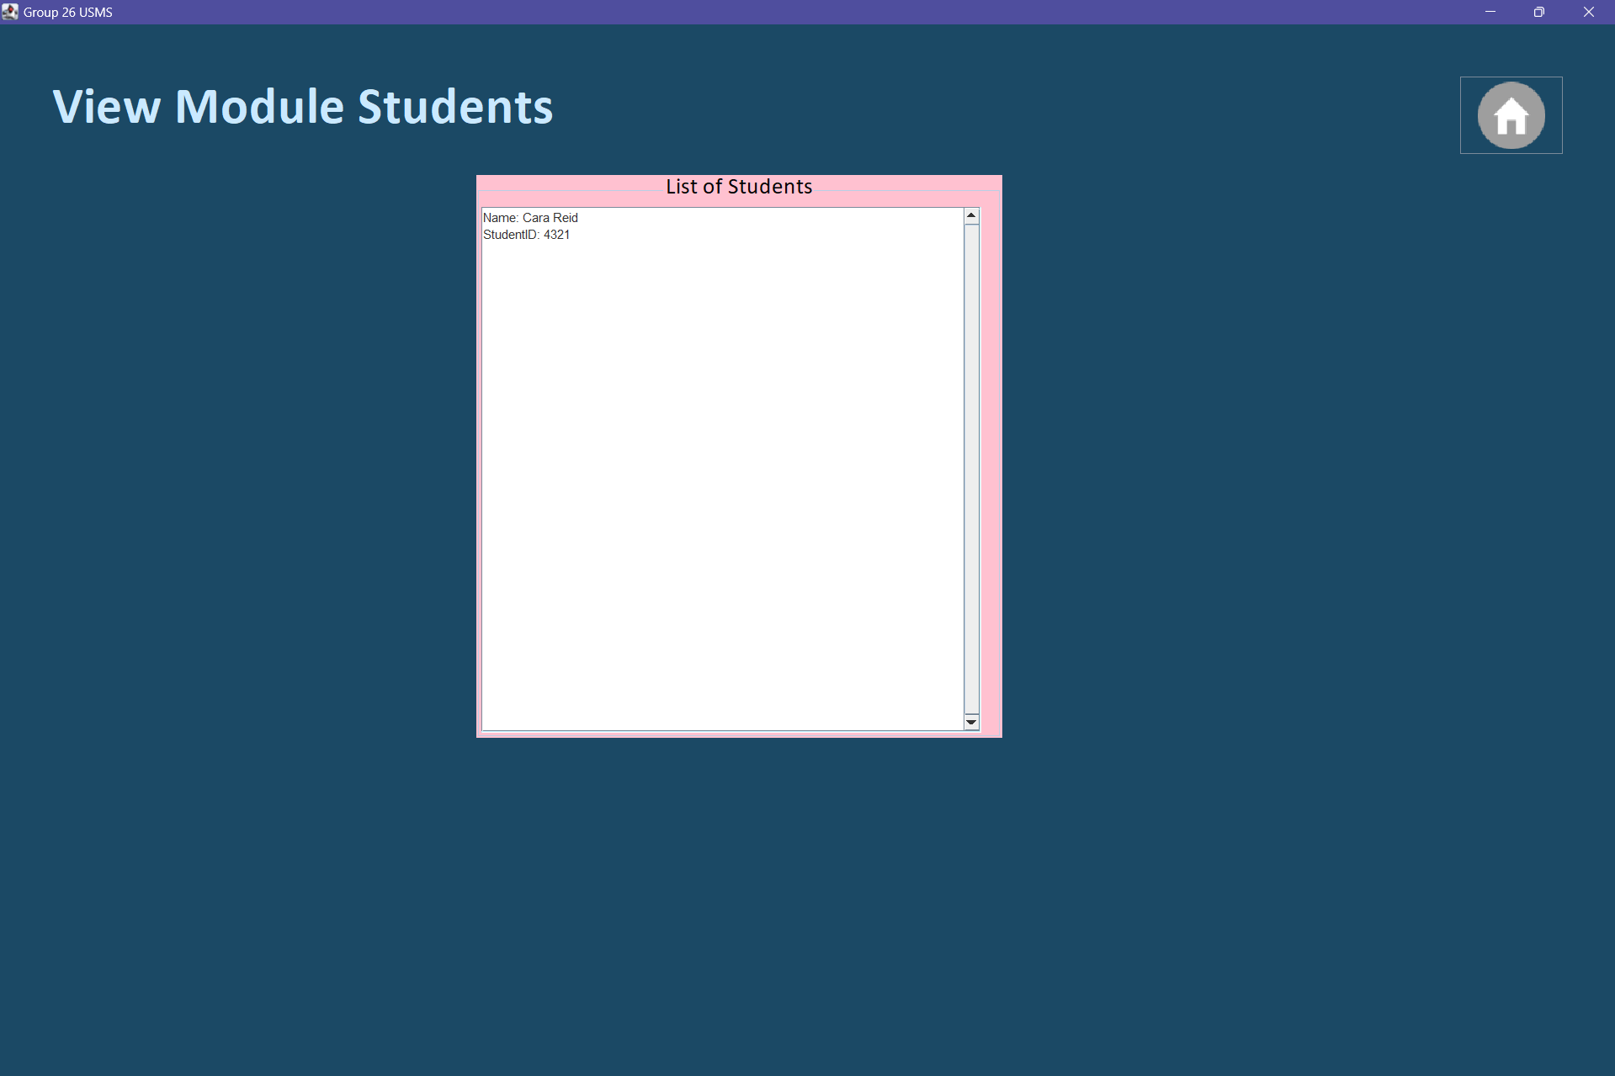
Figure 4.9, lecturer display of students in the lecturer’s module GUI

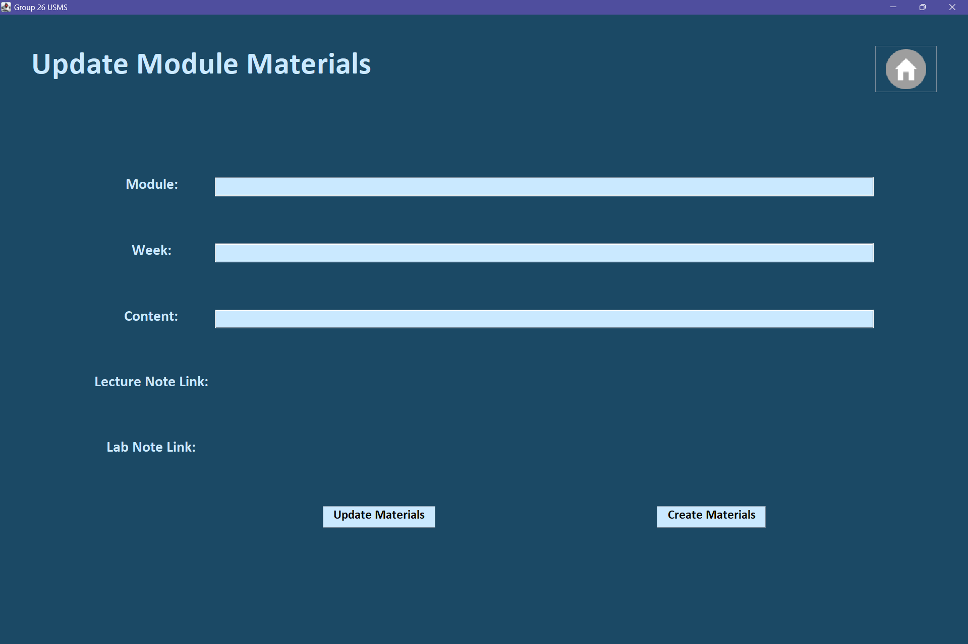
Figure 4.10, lecturer update module materials GUI

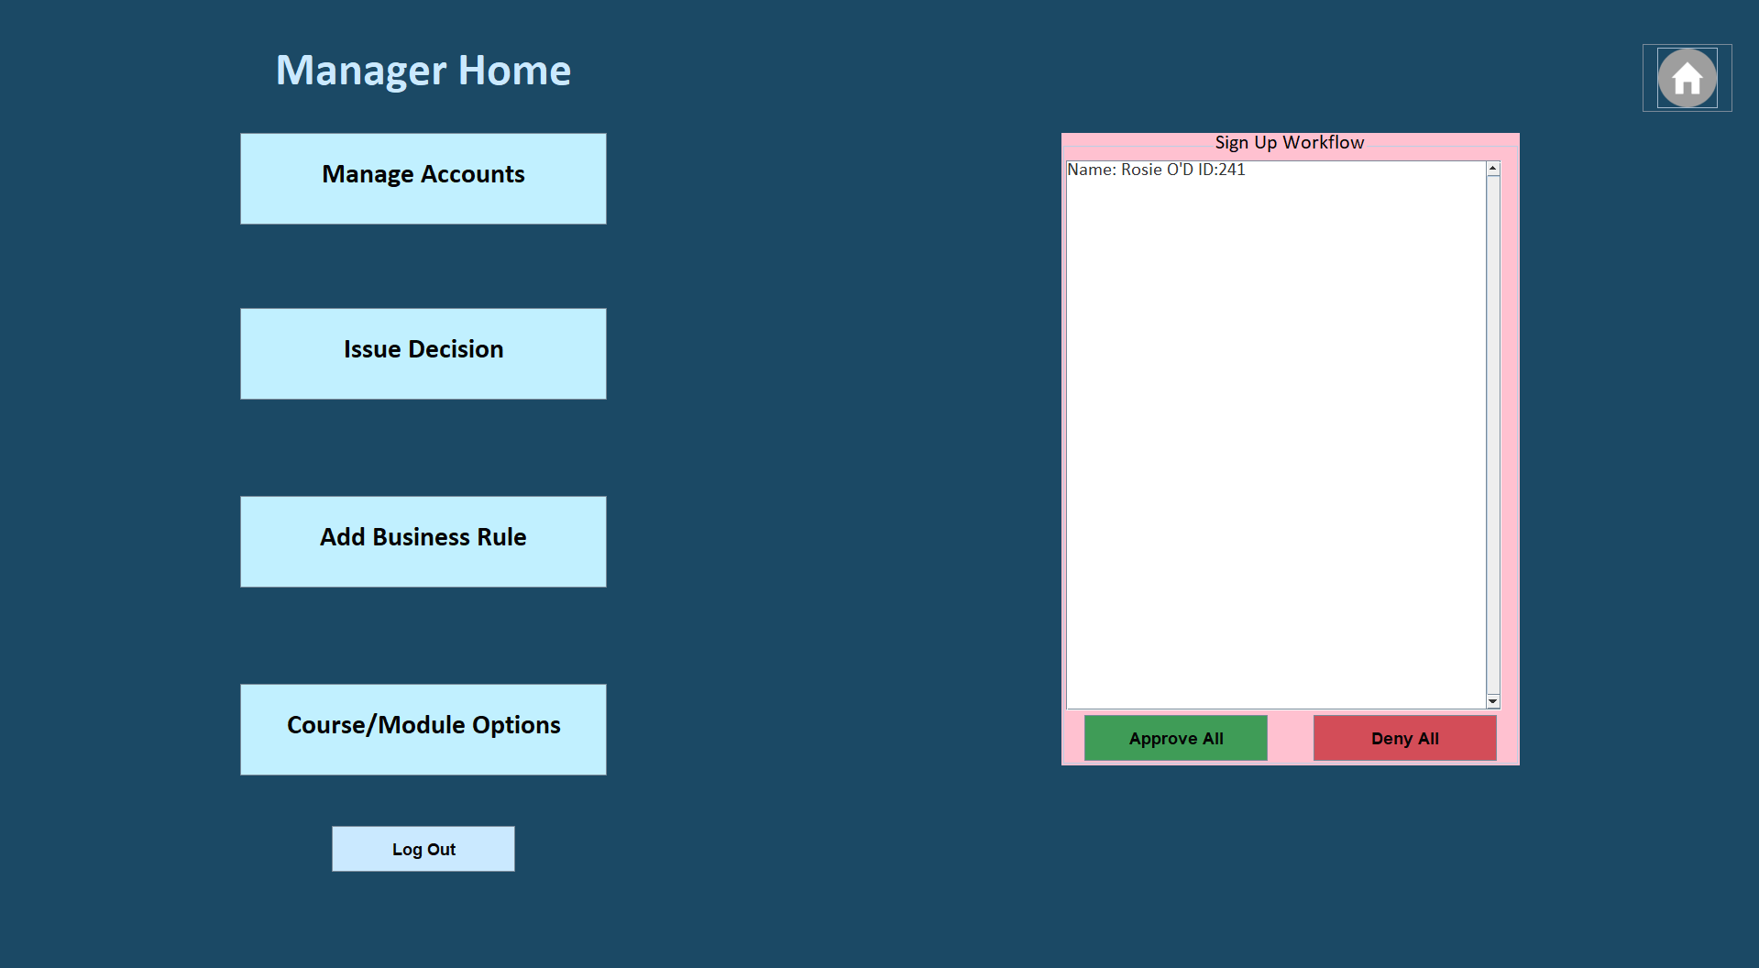
Figure 4.11, manager home page GUI
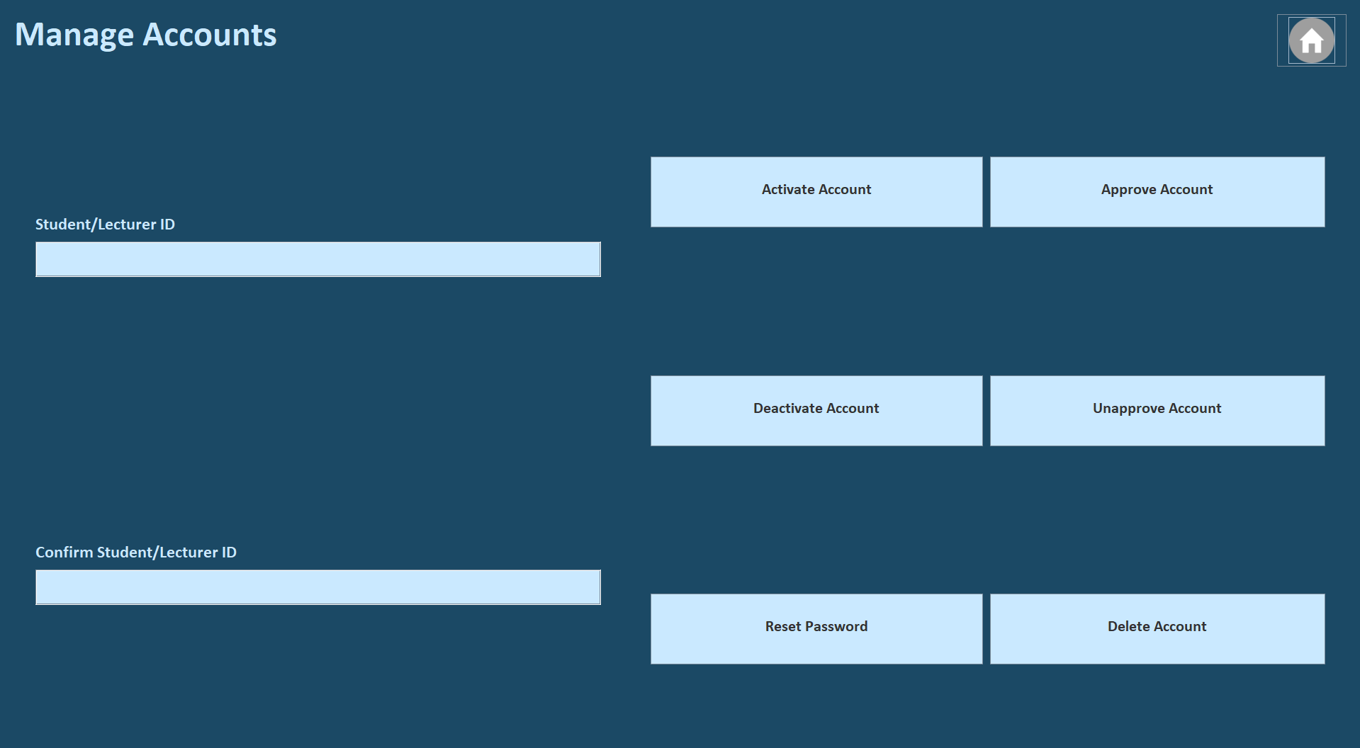
Figure 4.12, manager managing user accounts GUI

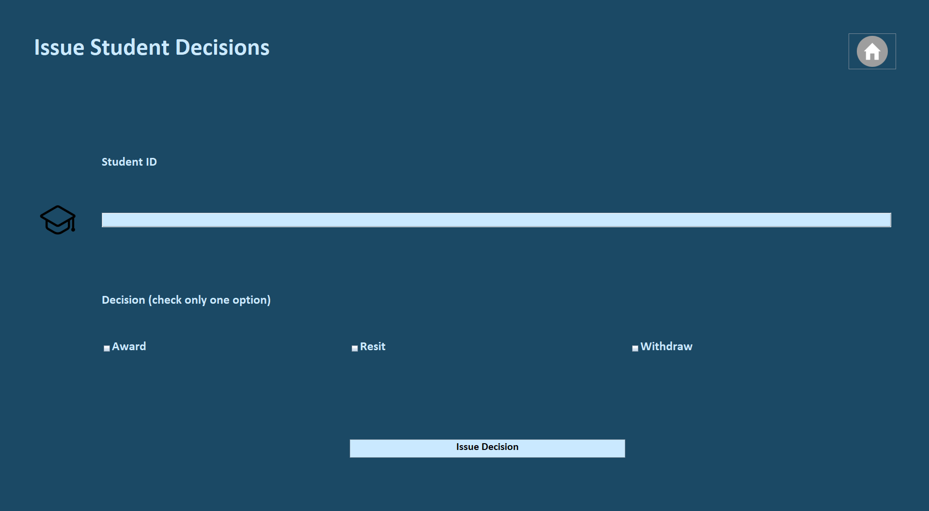
Figure 4.13, manager issuing student decisions GUI

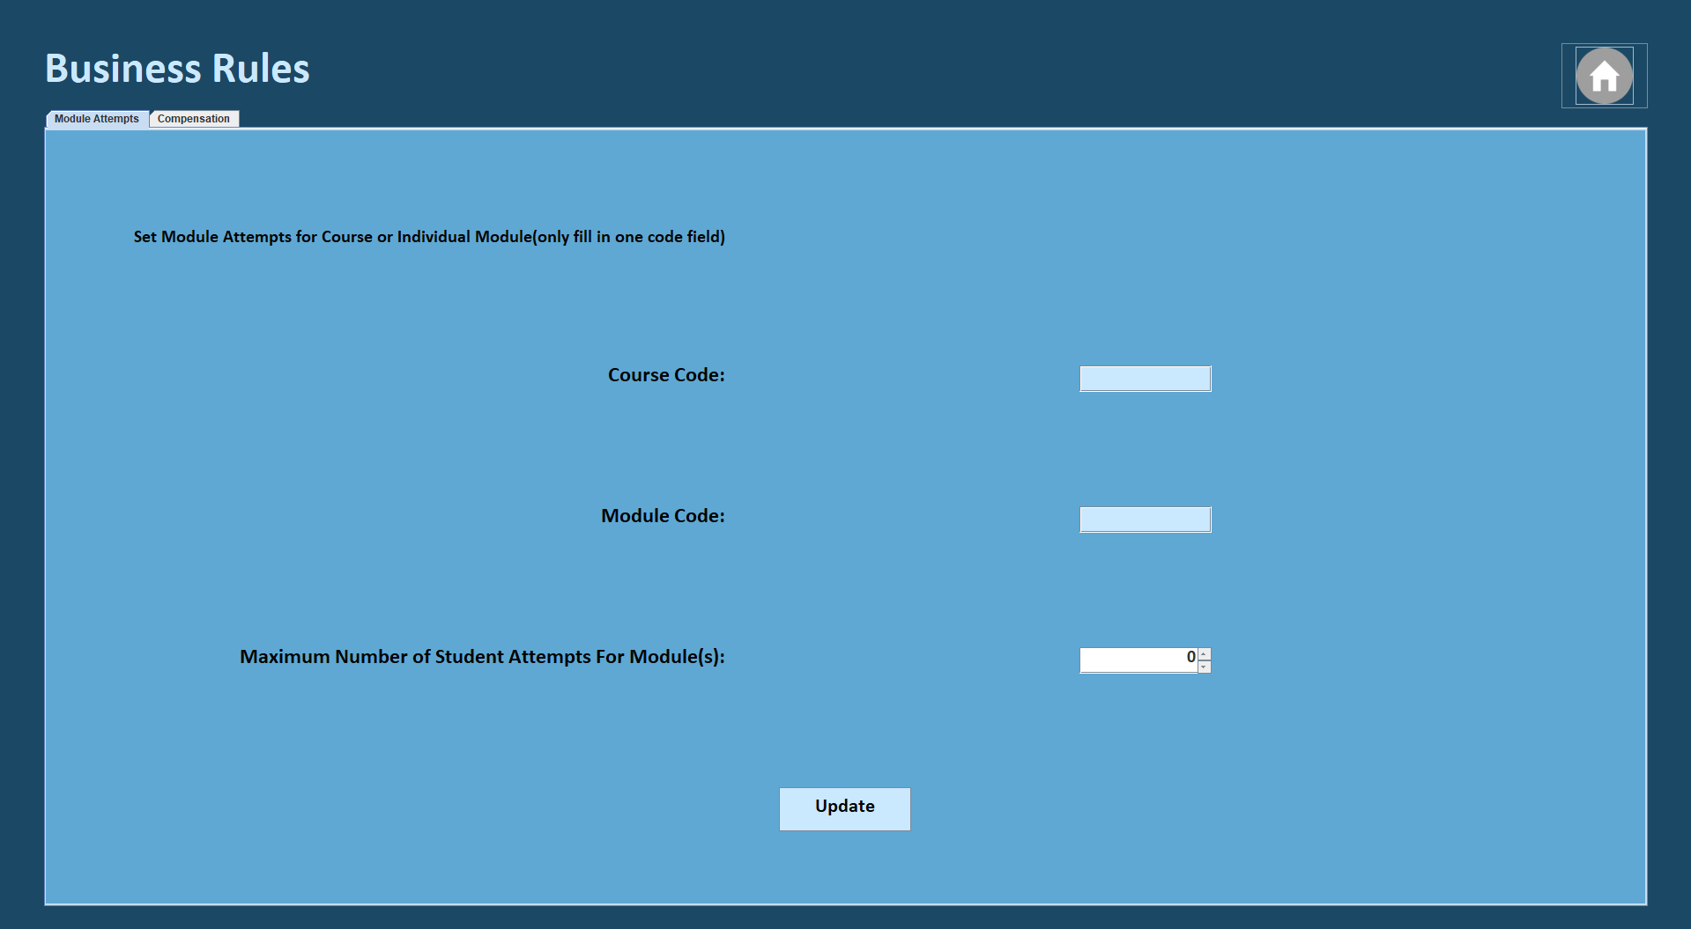
Figure 4.14, manager business rules GUI for module attempts
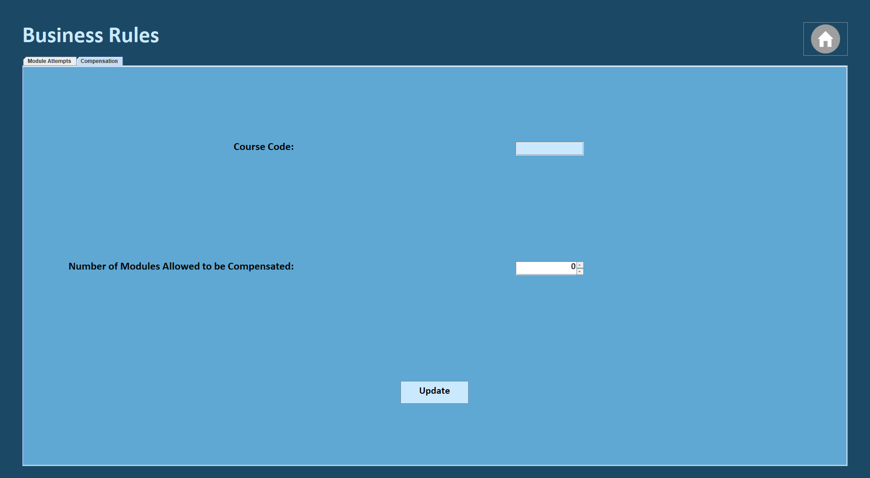
Figure 4.15, manager business rules GUI for compensation
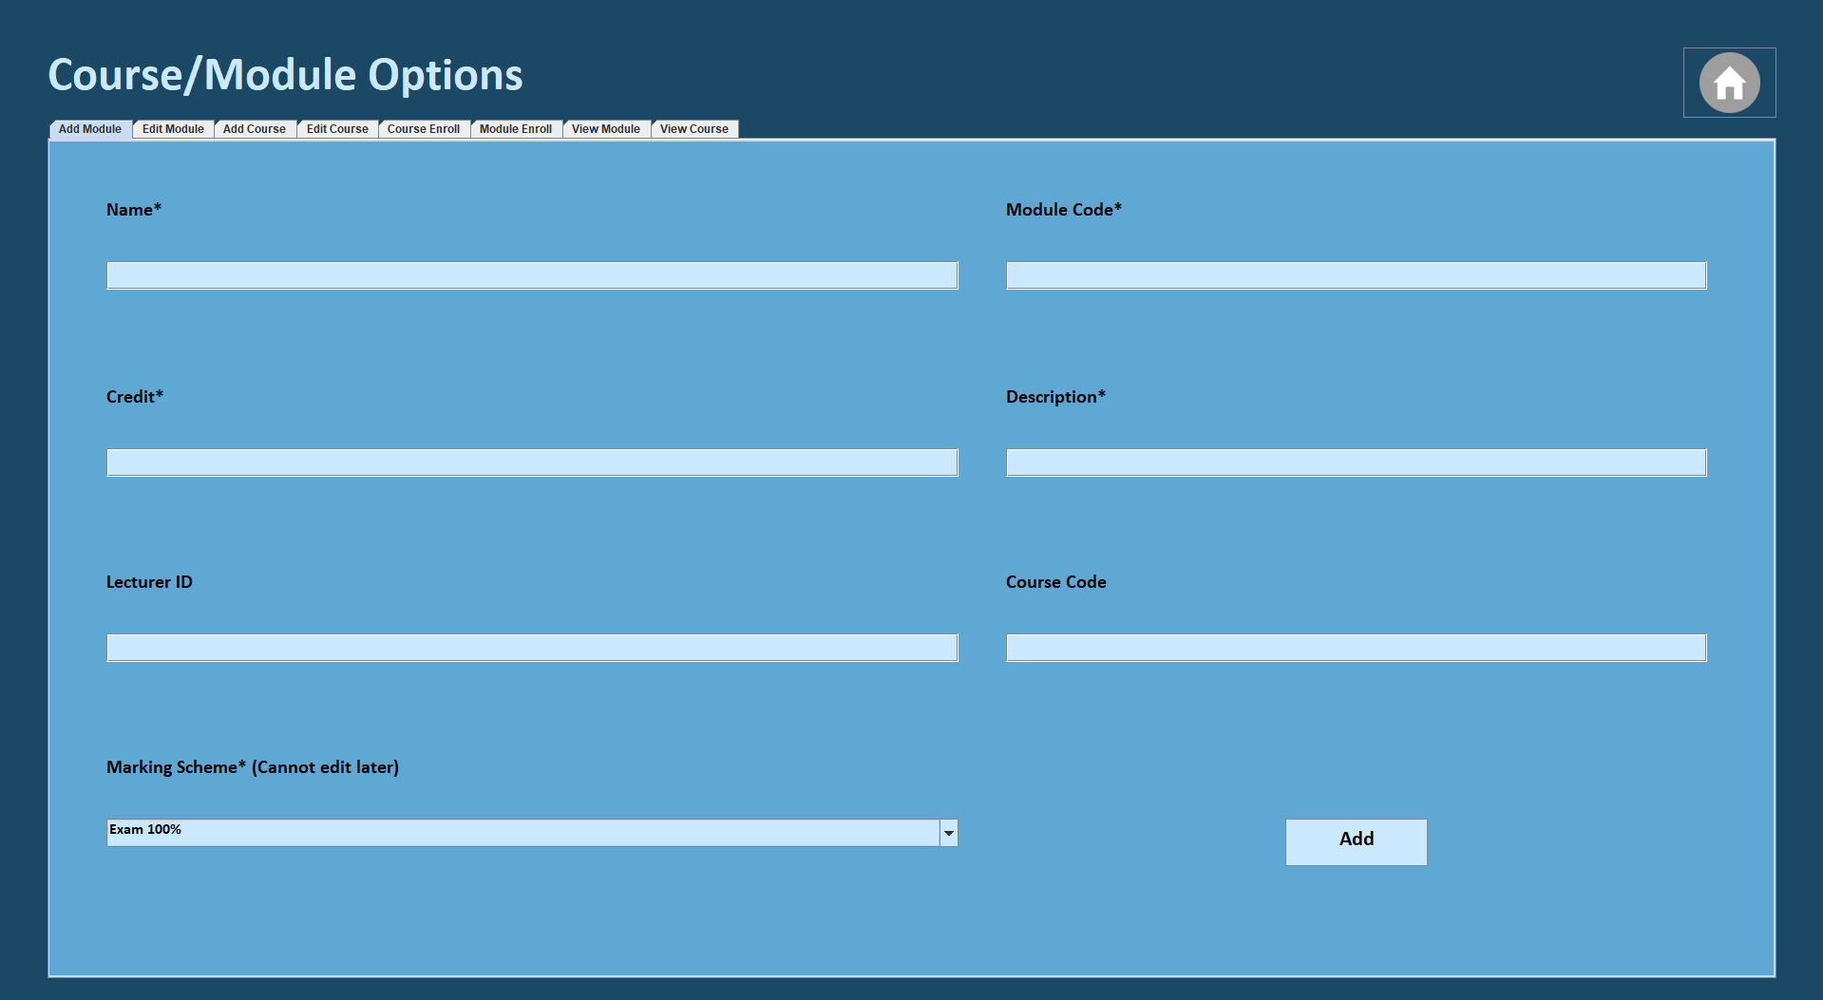
Figure 4.16, course/module options GUI for manager adding a module to the database

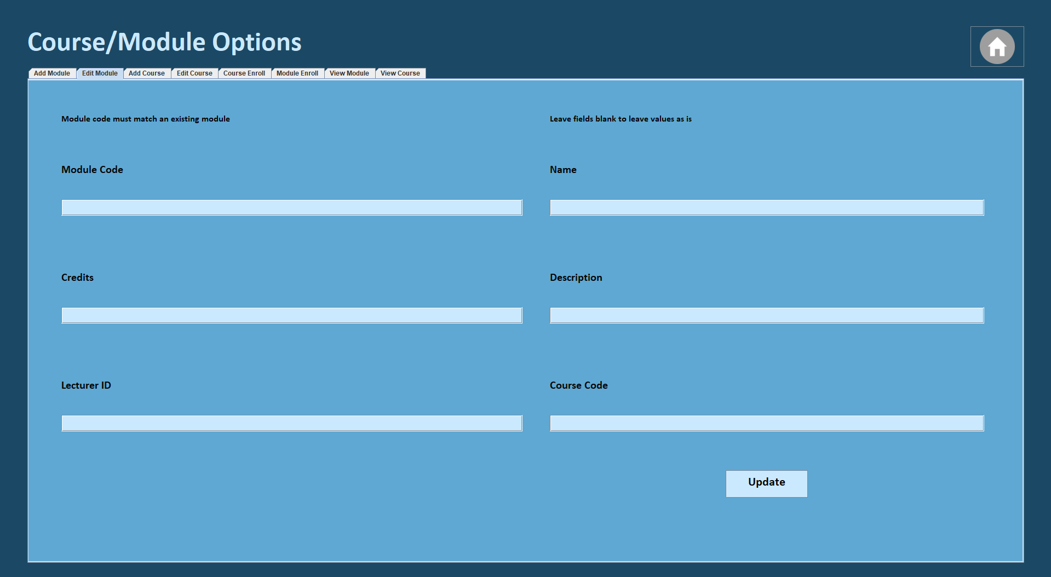
Figure 4.17 course/module options GUI for manager editing a module in the database

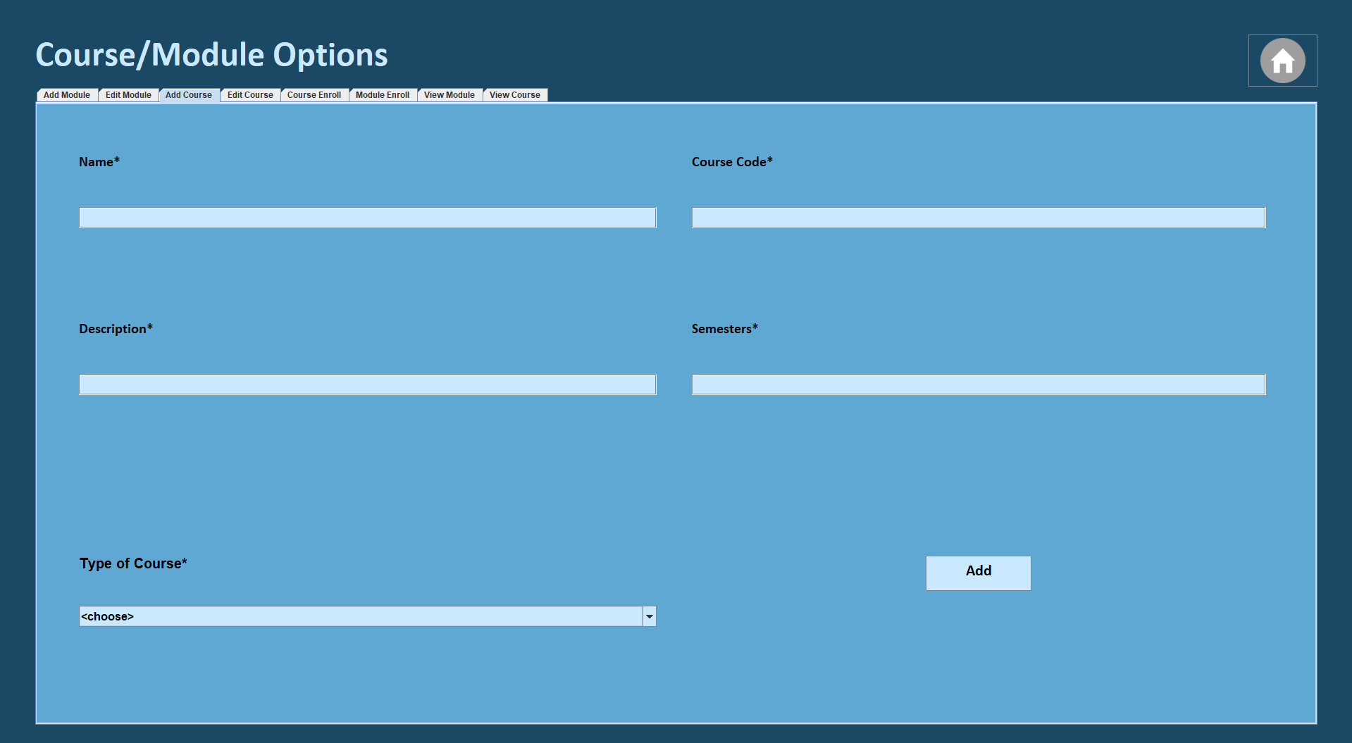
Figure 4.18, course/module options GUI for manager adding a course to the database
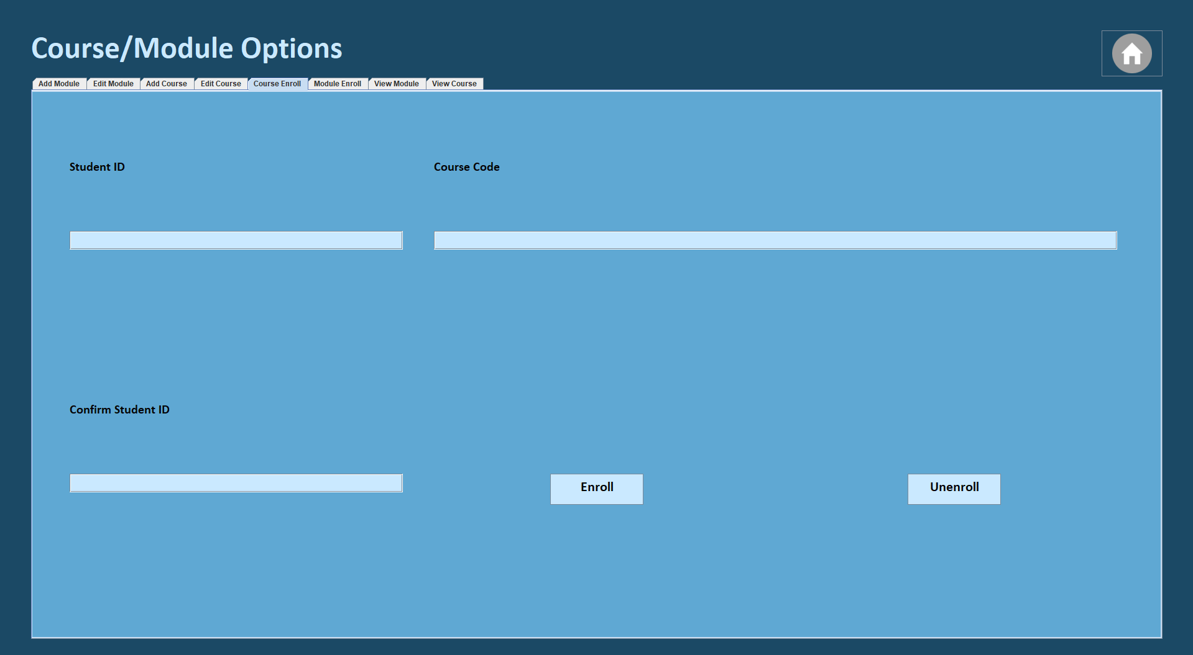
Figure 4.19, course/module options GUI for manager enrolling a student into a course

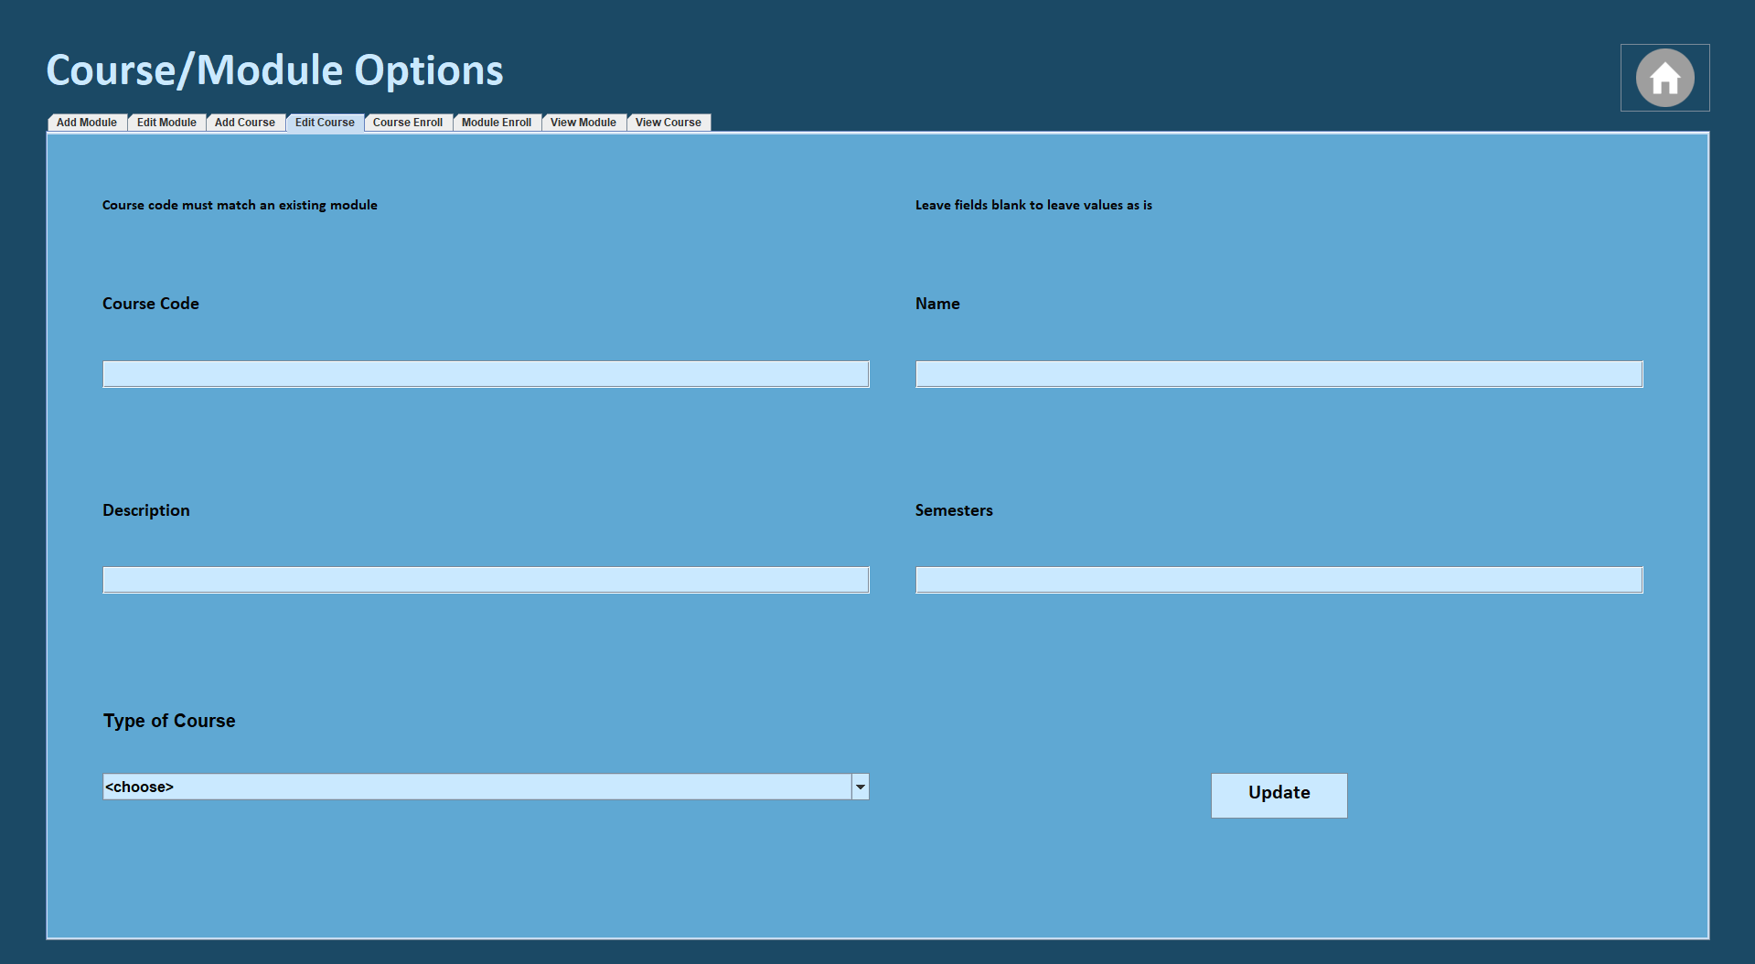
Figure 4.20, course/module GUI for manager editing a course in the database
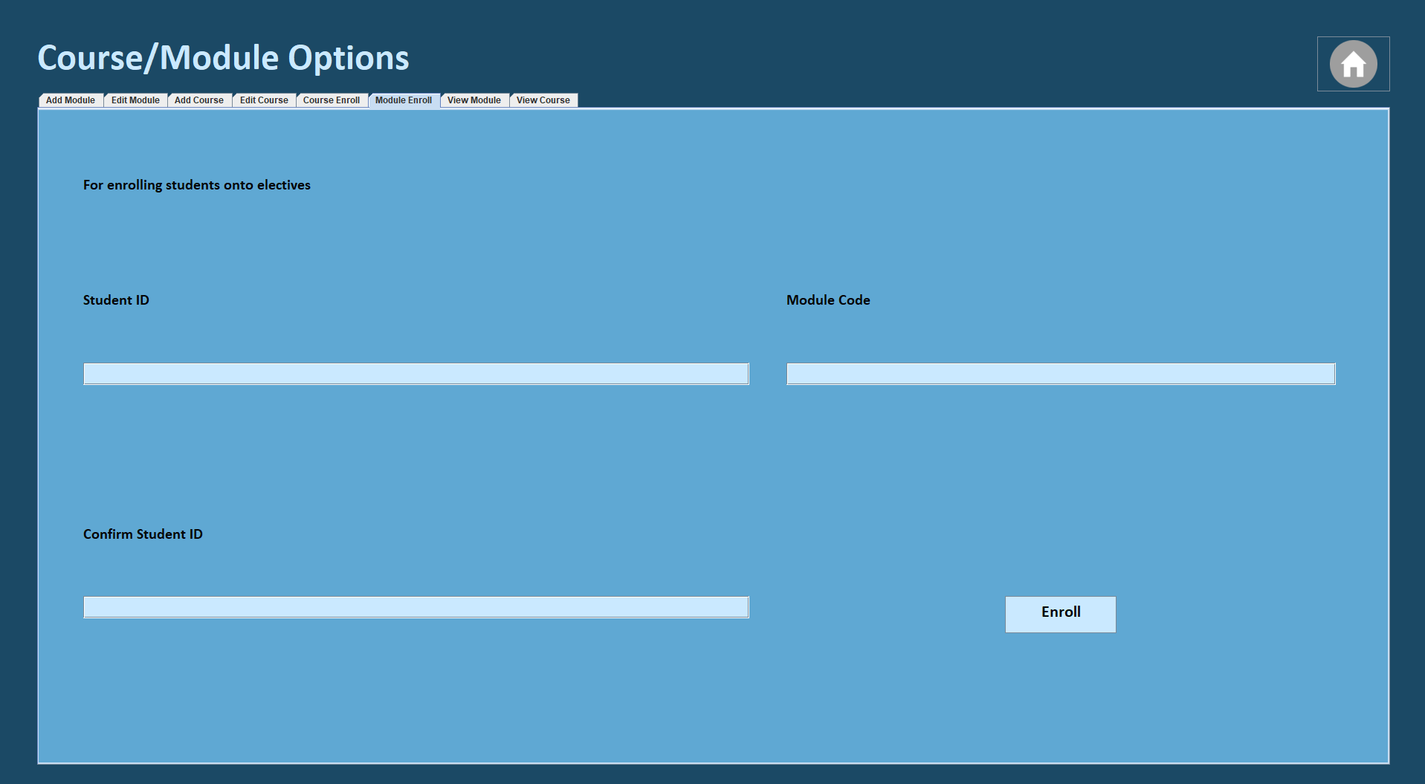
Figure 4.21, course/module GUI for manager enrolling students into modules
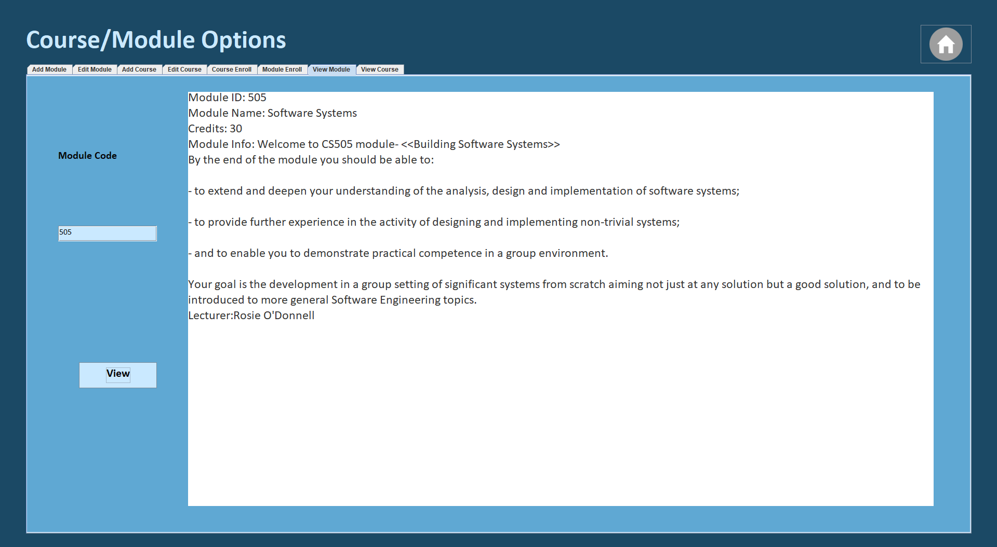
Figure 4.22, course/module options GUI for manager viewing a module
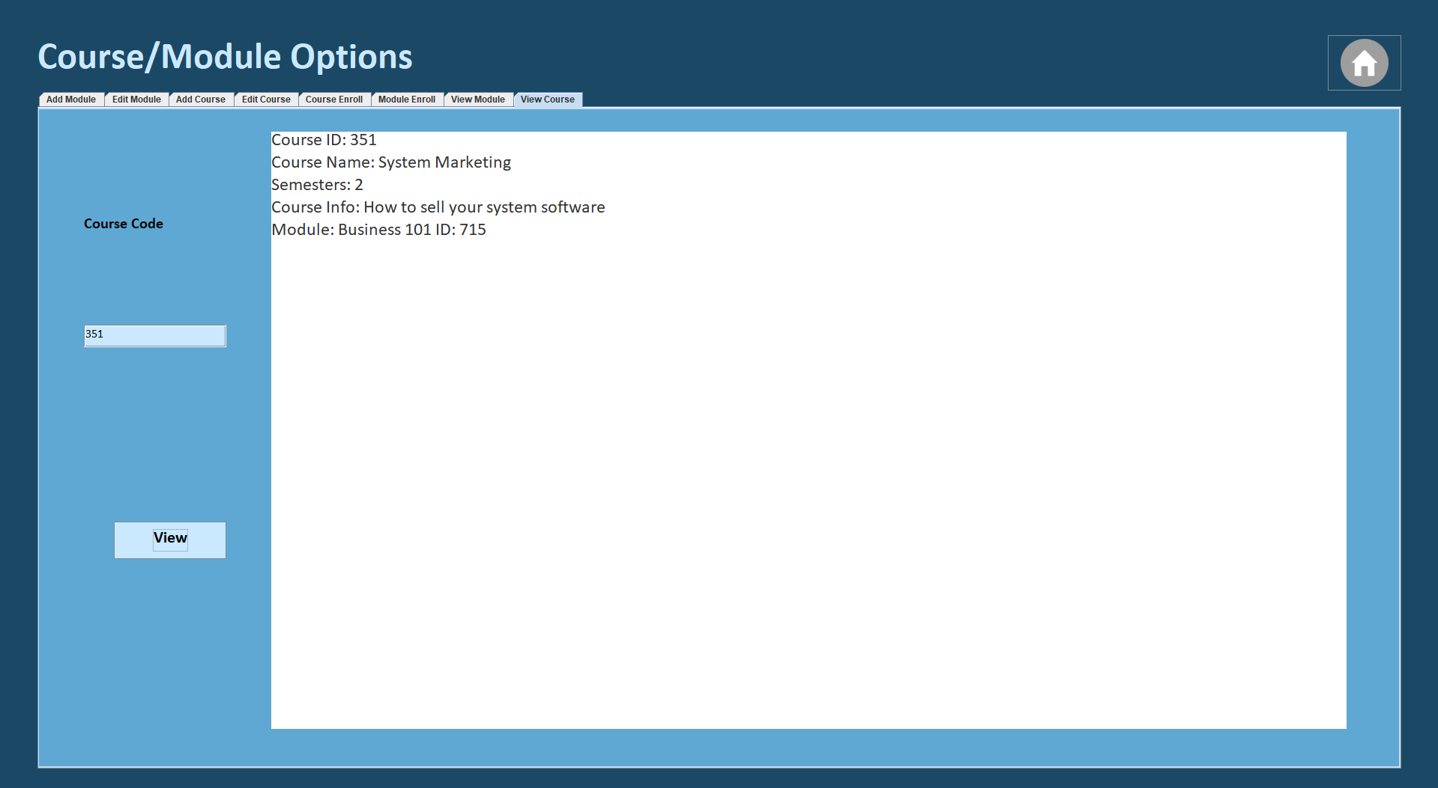
Figure 4.23, course/module options GUI for manager viewing a course

- Class diagram
Provide a list of classes and explain very briefly why these classes are required (reflect on the system requirements) for example,
  - Class User (Abstract): to handle user data and operations.
  - Class DatabaseConnection: to handle connection/operation to the database system.
  - Class StudentDAO: To handle all database interactions related to students (create, update or retrieve student data, etc).
  - Class LecturerDAO: To handle all database interactions related to lecturers.
  - Class ManagerDAO: To handle all database interactions related to managers.
  - Class ModuleDAO: To handle all database interactions related to modules (creating new modules, updating information on modules, etc)
  - Class CourseDAO: To handle all database interactions related to courses.
  - Class Module: To represent a module object in the system, including module information such as the max number of attempts that can be made.
  - Class Course: To represent a course object in the system, including the course details and the modules and students associated with the course.
  - Class Student: To represent a student object in the system, manages student specific actions (signing up as a student, viewing marks, etc).
  - Class Lecturer: To represent a lecturer object in the system, manages lecturer specific actions (viewing students in the module, editing the module, etc).
  - Class Manager: To represent a manager object in the system, manages manager specific actions (resetting passwords, approving users, etc).
  - Class Controller: To link together the models, DAOs and acts as the central coordinator for the systems operations.
  - Class Student Controller: To manage the operations and GUI interactions that are focused for student functionalities (such as viewing the modules they’re signed up for)
  - Class Lecturer Controller: To manage the operations and GUI interactions that are focused for lecturer functionalities (such as uploading content for the modules)
  - Class Manager Controller: To manage the operations and GUI interactions that are focused for manager functionalities (such as approving new sign-ups or adding new courses)
Then provide the class diagram as a separate image file called classDgrm.tiff or any other format such as pdf that can be zoomed in/ out to view each class and its methods.
- Test cases:
Provide system test cases that can test the complete scenario of each system use case (SUC) that you have described in subsection 3.2. Please note that these text cases are different from the test cases that you generated by using JUnit5 as the test cases generated by using Junit5 will be included in the test folder of your project that test individual units(classes). However, system test cases aim to test a complete scenario and not merely methods in a given class.

Test Criterion | Test Case | Test Input | Expected Output | Actual Output | Pass?
Test Sign Up Functionality | Check result for valid sign up values | Firstname: system  Surname: test  Email: systemtest@mail.com  DOB: 04-05-2002  Password: test  Confirm Password: test  Gender: Male  Degree Type: Undergraduate | Display Confirmation Message | A Confirmation Message is displayed | Yes
 | Check result for invalid sign up values | Firstname: John  Surname: Smith  Email: johnsmith@mail.com  DOB:  Password: pass  Confirm Password: pass  Gender:  Student Type: | Display Error Message | An Error Message is displayed | Yes
 | Check result for no sign up values | Firstname:  Surname:  Email:  DOB:  Password:  Confirm Password:  Gender:  Student Type: | Display Error Message | An Error Message is displayed | Yes
 | Check result for existing value | Firstname: system  Surname: test  Email: systemtest@mail.com  DOB: 04-05-2002  Password: test  Confirm Password: test  Gender: Male  Student Type: Undergraduate | Display Error Message | An Error Message is displayed | Yes

Test Criterion | Test Case | Test Input | Expected Output | Actual Output | Pass?
Test Log In Functionality | Check result for valid log in values | Role: Manager  Email: man@mail.com  Password: 1234 | Display Confirmation Message | A Confirmation Message is displayed | Yes
 | Check result for invalid log in values | Role: Student  Email: 123  Password: abc | Display Error Message | An Error Message is displayed | Yes
 | Check result for empty log in values | Role:  Email:  Password: | Display Error Message | An Error Message is displayed | Yes
 | Check result for non-existent record | Role: Lecturer  Email: test@mail.com  Password: test | Display Error Message | An Error Message is displayed | Yes

Test Criterion | Test Case | Test Input | Expected Output | Actual Output | Pass?
Test update exam results | Checking for:  Valid input response | LecturerID:  ModuleID:  MarkingScheme:  Credit: | Display Confirmation Message | A Confirmation Message is displayed | Yes
 | Check result for Invalid input response | Firstname: John  Lastname: Smith  Email: johnsmith@mail.com  DOB:  Password: pass  Confirm Password: pass  Gender:  Student Type: | Display Error Message | An Error Message is displayed | Yes
 | Check result for No input response | Firstname:  Lastname:  Email:  DOB:  Password:  Confirm Password:  Gender:  Student Type: | Display Error Message | An Error Message is displayed | Yes
 | Check result for Non-existing record response | Firstname: system  Lastname: test  Email: systemtest@mail.com  DOB: 04-05-2002  Password: test  Confirm Password: test  Gender: Male  Student Type: Undergraduate | Display Error Message | An Error Message is displayed | Yes

Test Criterion | Test Case | Test Input | Expected Output | Actual Output | Pass?
Test List Student’s Modules Functionality | Check that all modules are shown if a student is enrolled in modules | When logging in  Role: Student  Email: carapersona@gmail.com  Password: vineboom | Display a list of modules each taking the user to the correct module page | A List of the correct modules is displayed | Yes
 | Check that if a student has no modules a message is displayed | When logging in  Role: Student  Email: approve@amil.com  Password: done | A Message that there is not modules available | A message letting the user know that they are not enrolled in any modules is displayed | Yes

Test Criterion | Test Case | Test Input | Expected Output | Actual Output | Pass?
Test Manager add new course and module | Checking for Valid input response | Name: testModule  ModuleCode: 67  Credit: 20  Description: Test for adding a module  Marking Scheme Exam 50%, Lab(s) 50%: | Successful Message | A Confirmation Message is displayed | Yes
 | Check result for Invalid input response | Name: invalidTest  ModuleCode: qwert  Credit: 56  Description: asdfads  Marking Scheme: Exam (50%), Lab(s) 50% | Error Message | An Error Message is displayed | Yes
 | Check result for No input response | Name:  ModuleCode: 505  Credit:  Description  Marking Scheme: Exam | Error Message | An Error Message is displayed | Yes
 | Check result for existing input response | Name: testModule  ModuleCode: 67  Credit: 20  Description: Test for adding a module  Marking Scheme Exam 50%, Lab(s) 50%: | Display Error Message | An Error Message is displayed | Yes

